Design:
A Mission Patch to represent you OR your group.

Start in pencil. Then, add color.

Include your name OR your mission name.

You can include symbols to represent you, your group and your interests.

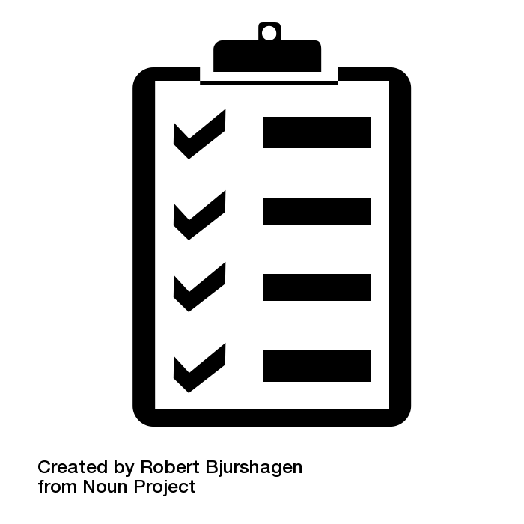
Directions:
Using the template, draw your patch.
> It must be in color.
> Three - four items/figures/words must be on the patch.
> Be original. Do NOT copy other NASA patches.
> Neatness is important. Put forth your best effort.
> Mission name and number are included.
> Name and Flight Director (Homeroom Teacher) must be on the page.

Think about it
- What is the name and number of your mission?
- What do you want the patch message to say to others?
- Keep it simple for all to see!
- Do you want words on the patch?
- What symbols will represent your mission?
- What colors would look good together on your patch?

DRIVER

Rover Driver Name: __________________ HR: _________________
Course: SPIRIT OR OPPORTUNITY Attempt (circle one) : First or second

Walk through the course. Write down the commands your rover should follow using the codes. Count your steps and be sure to list where the rover needs to make a turn on the course.

**When retrieving rocks, be sure to include a direction (Right, Left, Forward)!

The rover will ONLY be able to follow your written commands. You CANNOT change your commands once your rover has begun the course.

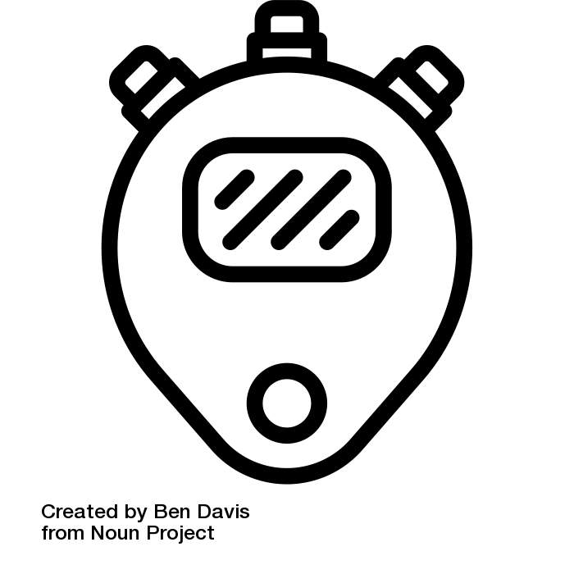
Your Mission:

- Safely navigate your rover as fast as possible on the Martian surface
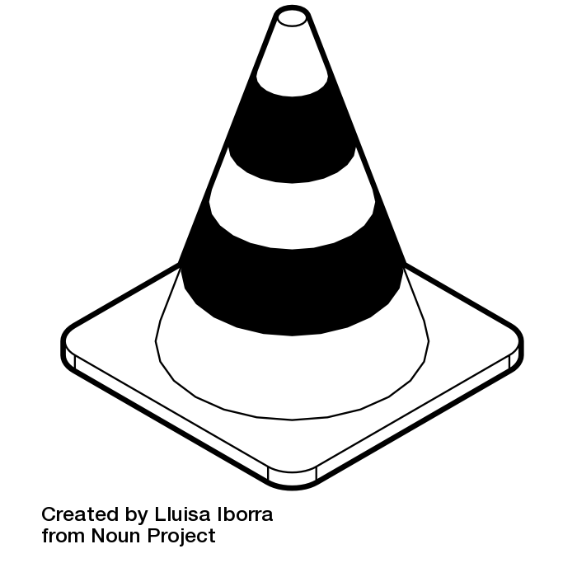

- Return rock samples (cones) to Earth for research

- Dangerous, rocky terrain and craters (Do NOT step on colorful dots
Rover Command Codes
Right R  Left L | Forward F  Backward B | Stop S  Rock Sample Retrieval RSR

Commands Example 1. F 3 steps. 2. Turn L 1 step. 3. RSR ®

**You DO NOT have to use all 31 commands. Use as many steps as you need!

1.  2.  3.  4.  5.  6.  7.  8.  9.  10.  11.  12.  13.  14.  15.  16. | 17.  18.  19.  20.  21.  22.  23.  24.  25.  25.  26.  27.  28.  29.  30.  31.
OFFICIAL
Rover Official Name: __________________ HR: _________________
Course: SPIRIT OR OPPORTUNITY Attempt (circle one) : First or second
Name of Rover Driver: _______________________
Name of Rover Members: ______________________________________

-> Say GO and start the stopwatch.

> As the Rover moves through the course:
- Record the number of foot faults by making tally marks in the chart below.
*Check that the driver is only reading the commands on their sheet!

> When your rover finishes:
- STOP the stopwatch. Record the total course time in the chart below.
- Count the total rock samples collected. Record it in the chart below.

Number of Foot Faults* | Total Course Time | Total Rock Samples Collected
 | ___:____.___

* Make a tally mark for every time the first person in your rover team steps on a tile.
**Grab from rover as they are collected. Return to course when complete.
Post Drive Reflection
As a team, evaluate your performance in each category on a scale of 1-5 (1=We need more practice, 5 = We are ready to go to Mars!)
Discuss the questions and record your answers on the lines below. Be specific.

Teamwork - We worked well as a team.

1 2 3 4 5

Problem-solving - We overcame difficulties/challenges well as a team.

1 2 3 4 5

Perseverance - We continued even when it was difficult.

1 2 3 4 5

Character - Our role assignments were a good fit for each of us.

1 2 3 4 5

Communication - We communicated well with each other.

1 2 3 4 5

What were some of the challenges your team experienced during your Rover Race?
__________________________________________________________________________________________________________________________________________________________________________________________________________________________________________________________________________________________________________________________________________

What do you think may have caused these challenges?
__________________________________________________________________________________________________________________________________________________________________________________________________________________________________________________________________________________________________________________________________________

What are the suggested changes for the Rover Team’s next drive?
________________________________________________________________________________________________________________________________________________________________________________________________________________________________________________________________________
__________________________________________________________________

